

King Fahd University of Petroleum and Minerals

College of Computer Science and Engineering

COE306: Introduction to Embedded Systems

**COE306 Project**

**Automatic A/C Controller**

**By:**

**Osama Bujwaied**

**201661700**

**For:**

**Dr. Hazim Selmi**

**Dr. Abdulaziz Tabakh**

2 May 2020

**Table of Contents**

**1. OBJECTIVE**  3

**2. PART LIST**  3

**3. BACKGROUND** 3

3.1 Arduino Uno 3

3.2 DS18B20 Temperature Sensor 3

3.3 Potentiometer 3

3.4 I2C Lcd Display 3

**4. STEPS OF PROJECT** 3

4.1 Connection And Programing Temperature Sensor 3

4.2 Reading User Temperature Request 3

4.3 Assigning Light To Show A/C Condition 3

4.4 Configure I2C LCD Display 3

4.5 Overall Design 3

5. **LINK TO VIDEO** 3

1. **OBJECTIVE**

The objective of this report is to exhibit automatic A/C controller unit that maintain requested temperature using Arduino equipment.

1. **PART LIST**
   * Arduino Uno R3 Device
   * USB cable
   * Jumper wires
   * Breadboard 3
   * LEDs (red, blue, yellow)
   * Adjustable Potentiometer
   * DS18B20 Temperature Sensor
   * I2C LCD Display

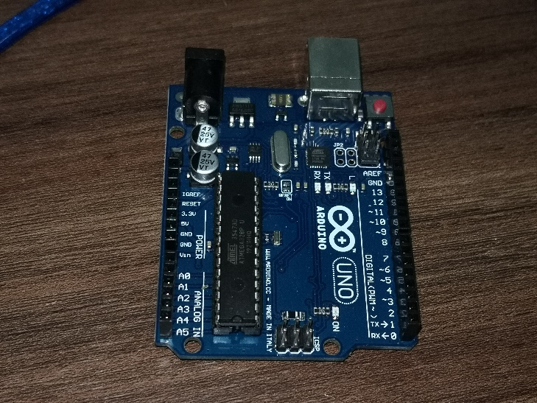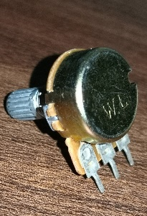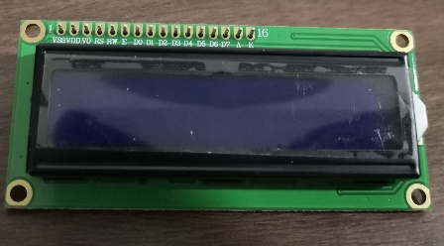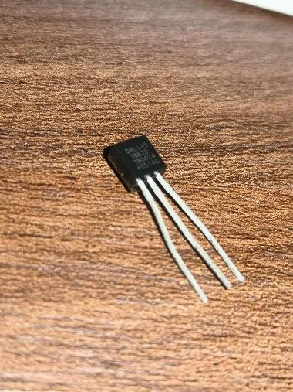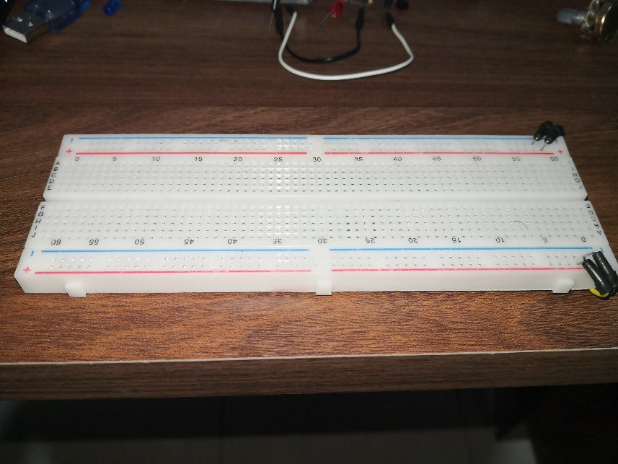

1. **BACKGROUND**

**3.1. Arduino Uno**

* In this project, I used Arduino Uno R3.
* It has 2 power source pins 3.3v and 5v in addition to 3 grounds.
* Also, it has 6 pins for analogy signal.
* In addition, there is 14 digital pins with 5 of them are PWM pins.

**3.2. Temperature Sensor**

* I used DS18B20 Temperature Sensor model.
* It has 3 wires. Left connected to the ground, Right to the voltage source. The middle connected to both power source using resistor and to digital to read it input.
* It can read operating temperature range: -55ºC to +125ºC, then it converts it to digital value.

**3.3. I2C LCD Display**

**3.5 Programing (code)**

* Function
  + Serial.begin(X); // Start serial communication with X speed
  + Serial.print(); // Print text or value to the console
  + analogRead (AX) // Read analogy value from analogy pin X.
  + analogWrite(X, Y)// Write Y value to PWM pin X.
  + delay(X) // Add some delay to code my X ms
  + sensors.begin(); // Start up the library for the sensors
* Library
  + OneWire
    - Used to connect temperature sensor.
  + DallasTemperature
    - Used to transform voltage temperature sensor value taken from the pin to Celsius value.
  + LiquidCrystal

1. **STEPS OF PROJECT**

**4.0. Orginize project component**

* Installing Arduino uno device above breadboard using rubber.
* Connect red(+) sign to 5v source in both direction, and Connect blue(-) sign to ground source in both direction.

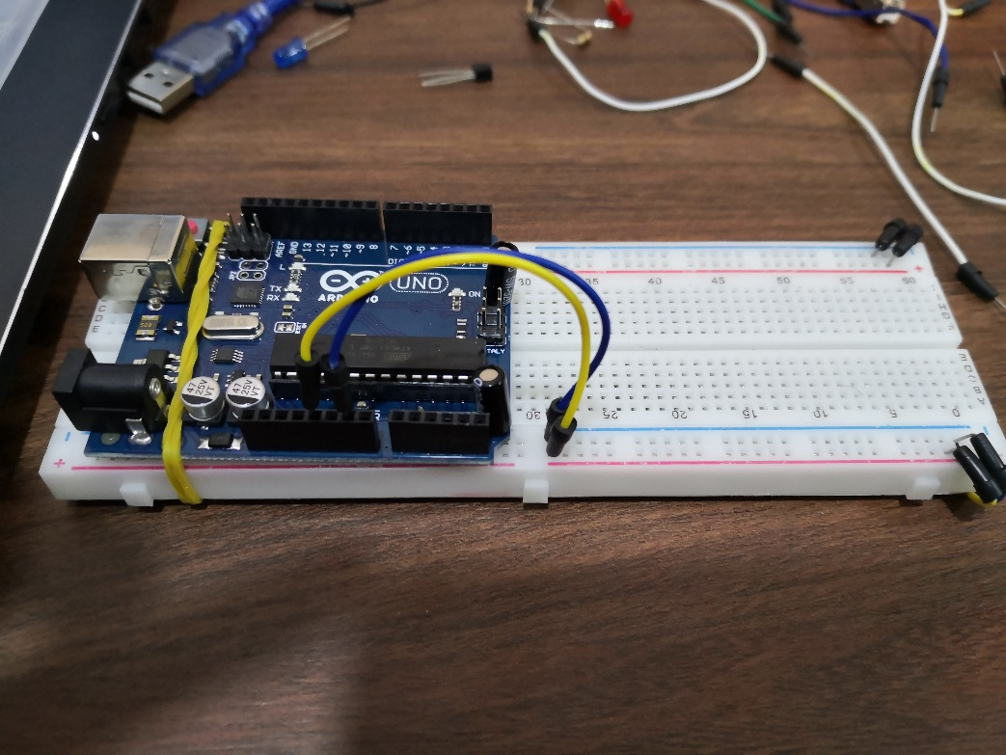

**4.1. Connection and Programing Temperature Sensor**

* **Code** 
  + Downloading OneWire and DallasTemperature libraries from Arduino program (Sketch > Include Library > Manage Library > "Search for OneWire and DallasTemperature libraries")

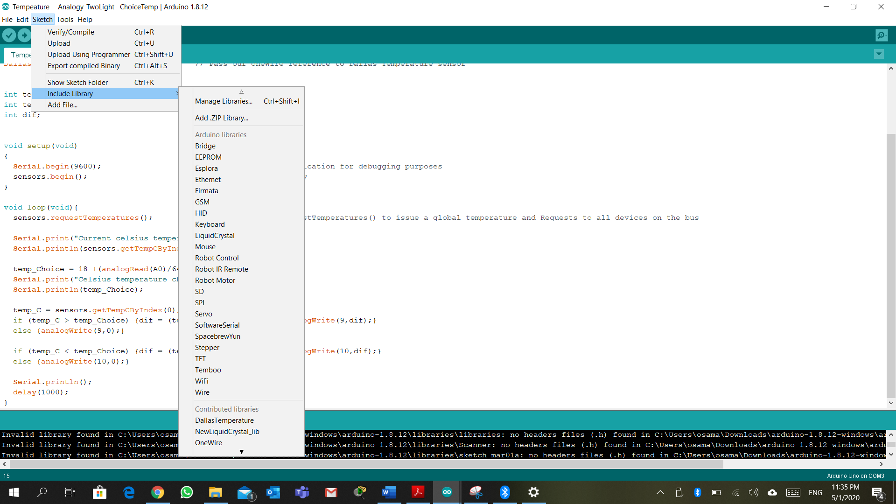

* + Assigning the needed code to read the temperature from sensor 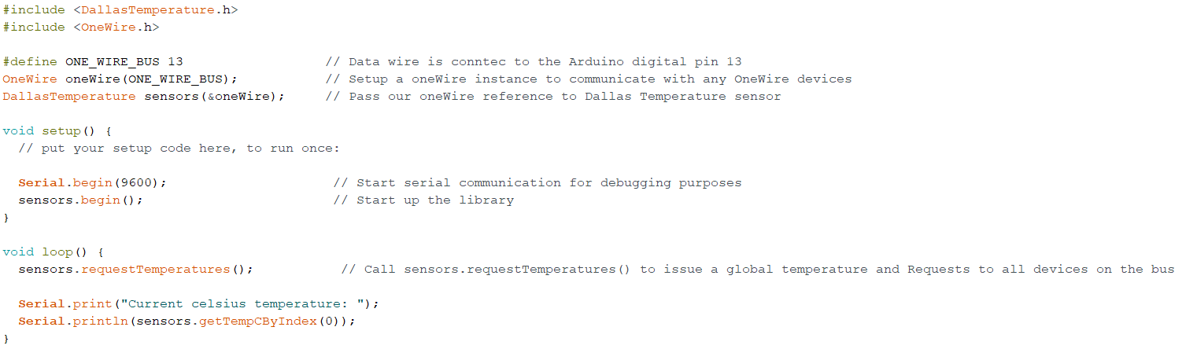
* **Device**

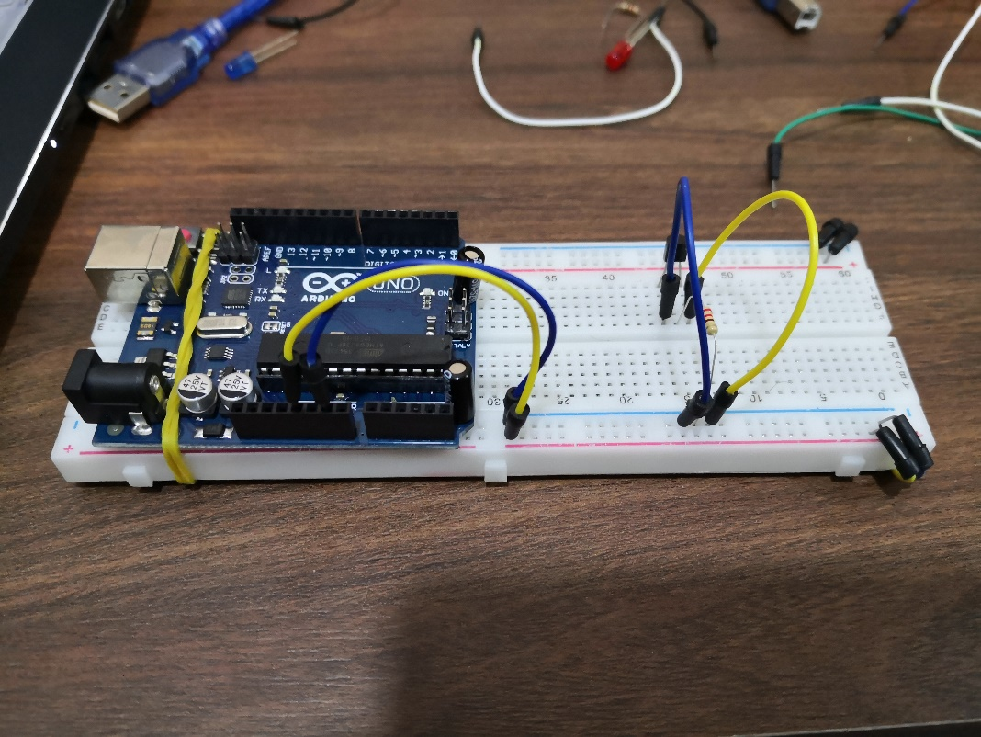

* + It has 3 wires connected as follow.
    - Left connected to the ground.
    - Right to the voltage source.
    - The middle connected to both power source using resistor and to digital pin 13.

**4.2. Reading User Temperature Request by Potentiometer**

* **Code** 
  + Making A0 as analogy input from Potentiometer
  + After Reading the analog value (0-1023) do this equation to it get a range of value between 18-33
    - Requested temperature = (A0/64) + 18

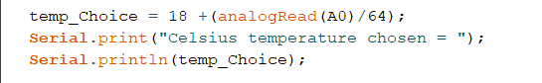

* **Device**
  + 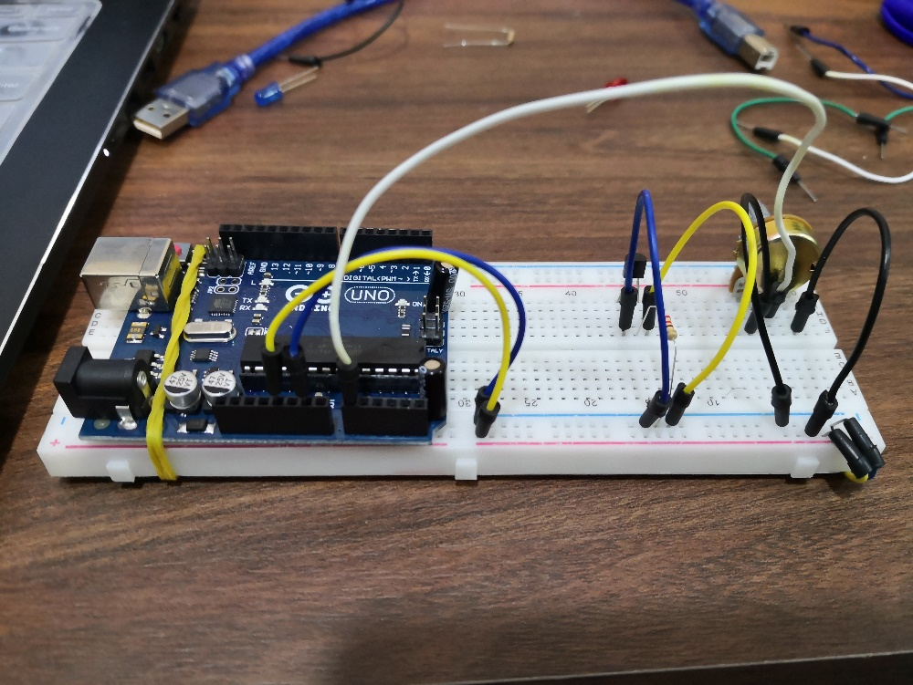
  + It has 3 wires connected as follow.
    - Left connected to the ground.
    - Right to the voltage source.
    - The middle connected to Analogy pin A0.

**4.3. Assigning Light to Show A/C Condition**

* **Code**
  + Making PWM digital pins 9 and 10 as output for the blue and the red light.
  + If reading temperature are greater than the requested temperature turn on the (Cold A/C) blue light.
  + If reading temperature are lower than the requested temperature turn on the (Hot A/C) Red light.
  + Increase the (fan speed) LED light intensity comparing to the different between requested and current room temperature

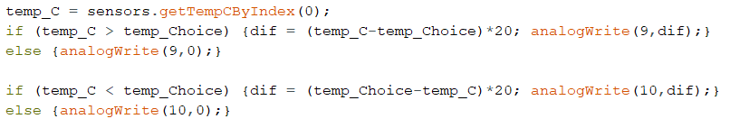

* **Device**

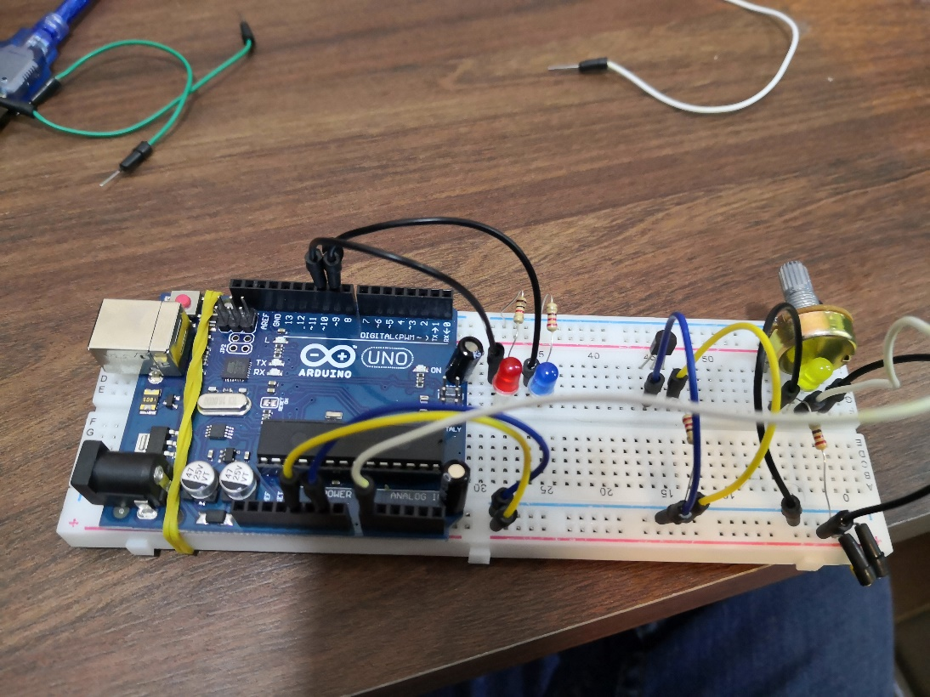

* + For both LED light connect (+) long wire to the digital pins 9 and 10, and the (-) short wire to the ground using a resistor.

**4.4. Configure I2C LCD Display to Show Temperature Condition**

**4.5. Overall Design**

